***Purple Slime's 5th Edition Character Menu***

***User Manual***

**General Information**

**Important Information About This Program**

Dungeons & Dragons: 5th Edition is a very complex game. This program is a supplement to the game that will work in conjunction with Dungeons & Dragons: 5th Edition Player’s Handbook or the System Resource Document. In order to get the most out of this program while playing Dungeons & Dragons, please refer to the Player’s Handbook that can be bought where books are sold or the [5e System Reference Document](https://5thsrd.org/) or the official [SRD pdf](https://dnd.wizards.com/articles/features/systems-reference-document-srd.) from *Wizards of the Coast*.

It is important to note that we are not Wizards of the Coast and will not be profiting off this material. We are publishing this under [Open Game License Version 1.0A](https://dnd.wizards.com/articles/features/systems-reference-document-srd).

**Getting Started**

**Installation Instructions**:

* Download the zip file for this program
* Extract the file from the zip file by right clicking the zip file and choose Extract
* Save the extracted file to the location on the computer you want to run it from.

**Minimum System Requirements**:

* Java Runtime Environment Java version 8 Update 181 has been installed on the system running the program

**Starting the Program:**

* To start the program, navigate to the location of the extracted file.
* Double click on the file named *PurpleSlimesCharacterMenu.jar*.

**Character Creation:**

Once the program opens, this screen will appear:

This is the character information screen. This will eventually hold all the information about the character. There are multiple parts to it. 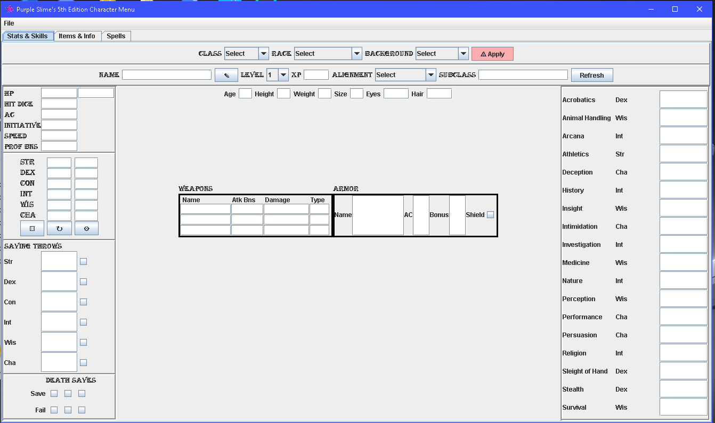

Steps to create a character:

* Choose a Race:
  + Races are the ancestry or species of the character being built. Each race has its own bonuses and features.
  + Select the race you want from the Race dropdown box
  + Please see the [SRD](https://5thsrd.org/) or the player’s handbook for a breakdown of the races
* Choose a Class:
  + Classes are the occupation or training of the character being built. Each class has its own bonuses and features.
  + Select the class you want from the Class dropdown box
  + Each class has subclasses which will allow the character to specialize in their class.
    - Subclasses are chosen via the subclass choice box that will appear at the appropriate level for each class
    - Be very careful choosing the subclass of a character, as this can not be undone unless the character is recreated, especially once the character is past level 1.
  + Please see the [SRD](https://5thsrd.org/) or the Player’s Handbook for a breakdown of the classes
* Choose a Background:
  + Backgrounds are the characters history or origin of the character being built. Each background has its own bonuses and features.
  + Select the background you want from the Background dropdown box
  + Please see the [SRD on Backgrounds](https://5thsrd.org/character/backgrounds/) or the player's handbook for a breakdown of the backgrounds
* Choose a Name:
  + This is what your character will be called.
  + Type the name for your character into the name field
  + Press the pen icon to set the name
  + If a name is used is the same as a previously existing character, the previous character will be overwritten.
    - It is recommended that each character have a unique name
* Roll for Ability Scores (Optional)
  + Ability scores are not required to be rolled before a character is created, but some people prefer to have them for creation.
  + Please see the [SRD on Ability Scores](https://5thsrd.org/rules/abilities/ability_scores/) or the *Player's Handbook* for more on Ability Scores
  + To roll ability scores in Purple Slime’s Character Menu, please see Rolling Ability Scores
* Choose an Alignment (Optional)
  + Alignment is how the character views the world and interacts with it.
  + Please see the [SRD on Alignment](https://5thsrd.org/character/alignment/) or the player's handbook for more on Ability Scores
  + This is not required to create a character, but is generally chosen at this time.
* Other Character Information (Optional)
  + Below the character creation choice bars is a set of fields for other information about the character.
  + These fields are not required at any time, but some players may want to fill in the information for later use.

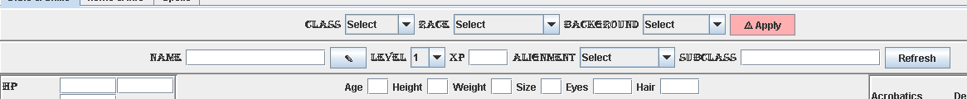

* Click Apply
  + This will create a level 1 character that has the race, class background and name you chose. It will add all the bonuses, features, equipment and information to the character for you.
  + At this point, depending on the class, race and background of the character, you may be asked to make some choices about the character. These choices will appear as a series of pop up boxes

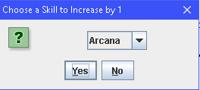

* + The choices can include:
    - Languages - [SRD - Languages](https://5thsrd.org/character/languages/)
    - Skills - [SRD - Ability Checks](https://5thsrd.org/rules/abilities/ability_checks/)
    - Spells - [SRD - What is a Spell?](https://5thsrd.org/spellcasting/what_is_a_spell/)
    - For information on these, please see the Class information in the [SRD](https://5thsrd.org/)
      * Equipment
      * Class Specific choices
      * Subclass
        + Once this is chosen, the subclass field will automatically fill in
      * Subclass Specific Choices
  + For more information on the choice and what the options are, please refer to the SRD.
    - Most boxes will have the type of choice across the top of the box
    - Some choice boxes may have more than one choice per box
    - 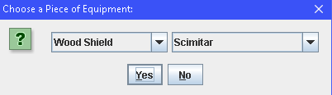
  + Once you decide which answer you want, click the drop down to choose that selection and click yes.
  + When all the choice boxes have been selected, the characters information will be displayed.

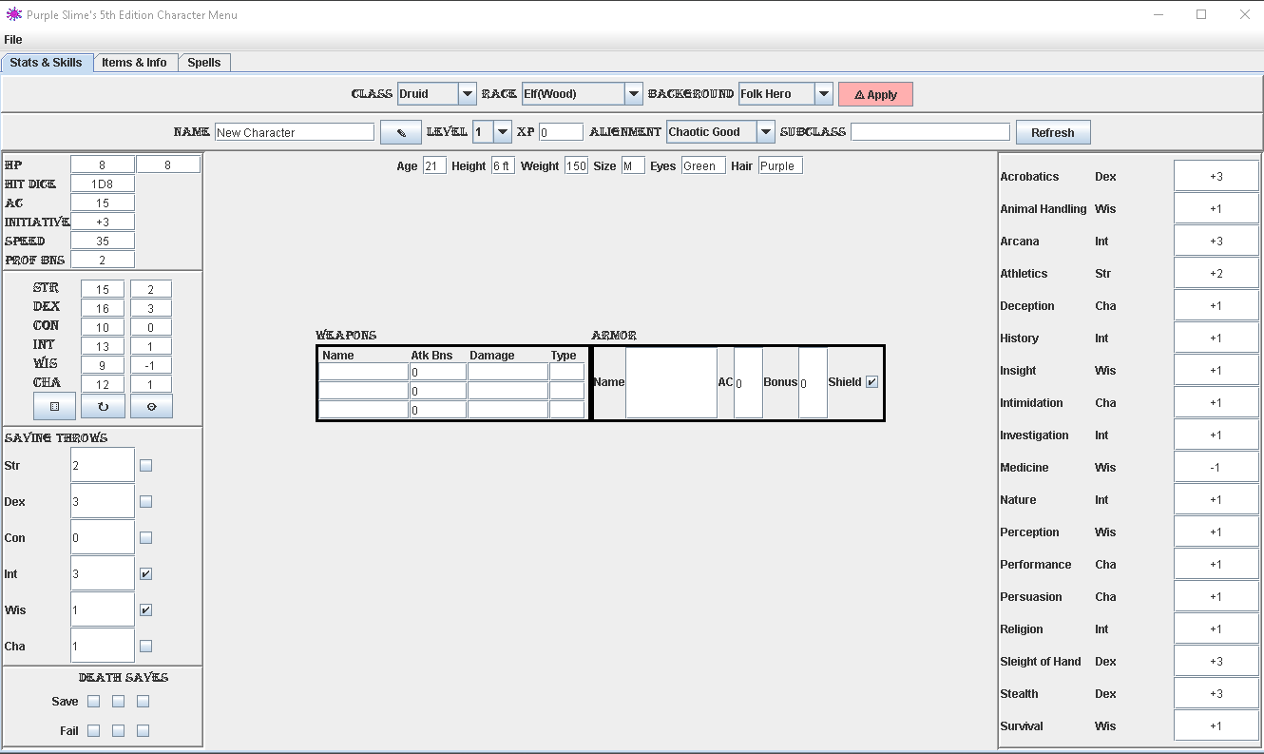

If you are unhappy with your newly rolled character, simply make any changes you wish and hit reapply. The character will be recreated and all values set back before the choices were made and any other information you have manually entered.

**Rolling Ability Scores:**

Ability scores are the representations of your character between 1 and 20 in a given characteristic. The higher the number, the better your character is in that ability. This choice can also be before the character is created, after the character is created or changed after the character is created. Please check with your Dungeon Master on rules about changing these values after the game has begun. For more information on Ability scores, please see [SRD on Ability Scores](https://5thsrd.org/rules/abilities/ability_scores/)

The abilities are:

* Strength - The strength of the character
* Dexterity - The agility of the character.
* Constitution - The stamina of your character
* Intelligence - The character’s ability to reason and remember
* Wisdom - The character’s perception of situations
* Charisma - The characters personality

To determine the ability points for the character.

* Click on the cogwheel in the ability point panel.

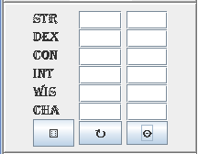

* A pop up box will appear and ask how you would like to choose your ability points.

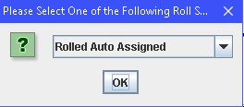

* + Rolled Auto Assigned
  + The program will roll the ability points and assign them to the different abilities automatically
  + If this method is chosen
    - Click the dice in the ability score box
    - The scores will appear in the ability point boxes.
  + Rolled User Assigned
  + The program will roll 6 values for the character and you are allowed to determine which score goes to which ability
  + Each number should only be applied once
  + If this method is chosen
    - Click the dice in the ability score box
    - The Roll Assignment box will appear

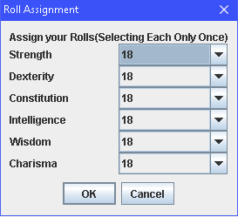

* + - To use this, click the drop down next to each skill and assign the values. Then click OK

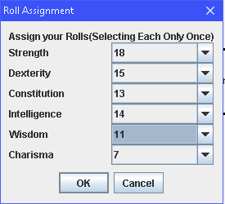

* + - The scores will appear in the Ability Score boxes as they were assigned  
      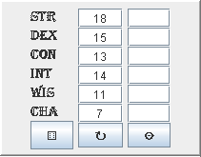
  + Standard Array
  + This will return a standard set of values for the ability scores of 15, 14, 13, 12, 10, 8
  + These scores can be assigned by the user to the different ability scores
  + Each number should only be applied once
  + If this method is chosen
    - Click the dice in the ability score box
    - The Roll Assignment box will appear

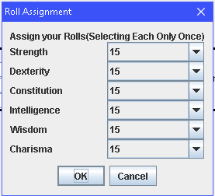

* + - To use this, click the drop down next to each skill and assign the values. Then click OK

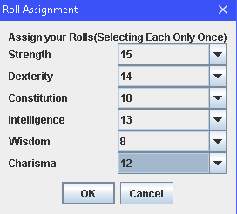

* + - The scores will appear in the Ability Score boxes as they were assigned  
      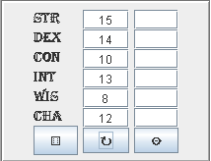
* Once the skills have been assigned, if apply has not been clicked, then skills will wait till the character is created.
* When the character is created or if the skills are chosen after the apply button has been hit, the ability scores will be used to calculate numerous values for the character. In the Ability Score box the set of numbers closest to the ability score name is the actual ability score. The second set of numbers is the Ability Score Modifier, which is also described in the [SRD on Ability Scores](https://5thsrd.org/rules/abilities/ability_scores/).

**Reading the Character Screen:**

After you have created a character, the character screen should look something like this:



*Breakdown of the Stats and Skills tab*

* Character information box

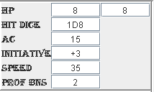

* + This box contains:
    - Hit points how many the character has left compared to their max
    - Hit dice specific to the class.
    - Armor class (AC) - how much armor the character is wearing
    - Initiative used in combat
    - Speed - how far can the character travel in one turn
    - Proficiency bonus - how capable the character is
      * Determined by level
* Saving Throws

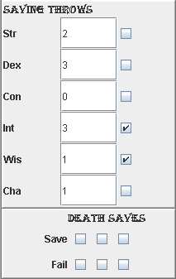

* + These are used to get out of something unpleasant.
  + The check marks represent the skills the character’s chosen class is proficient in and are set when the character is created.
  + For more information, please see [SRD - Saving Throws](https://5thsrd.org/rules/abilities/saving_throws/)
* Skills
  + This is the skills that are possible for a character to be proficient in. Each line consists of the skill, the ability score that is linked to that skill and the modifier for that skill. For more information on the skills please see [SRD - Ability Checks](https://5thsrd.org/rules/abilities/ability_checks/)

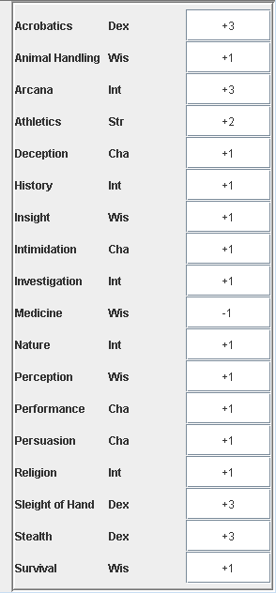

* Weapons and Armor

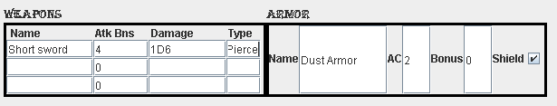

* + These are the weapons and armor the character is currently wearing.
  + When your character decides to equip a weapon or armor, enter them here.
  + These values are manual entry and not tied to the equipment list. At the same time, the check box for the shield is determined by the equipment list.
  + When entering Armor, the AC value will be calculated into the character’s AC value on the next save of the character.
  + The information from these boxes will only be applied to the character when the character is built or saved.
  + For more information on the weapons or armor, please see
    - [SRD - Armor](https://5thsrd.org/adventuring/equipment/armor/)
    - [SRD Weapons](https://5thsrd.org/adventuring/equipment/weapons/)

*Breakdown of the Items and Info tab*

* Subclass Features

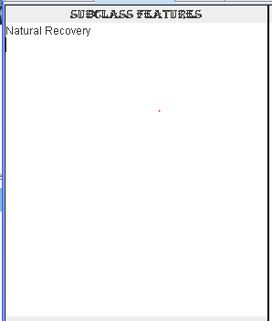

* + This is where any features given to the character based on their subclass will be placed
  + These values are entered automatically
* Languages

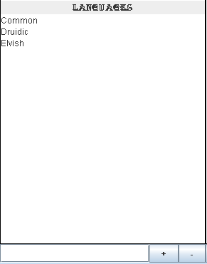

* + These are the languages the character knows.
    - A character must be built or loaded for this box to work
    - Do not use colons in the text to be entered
      * This will cause any information after the colon to not be saved correctly
    - Some classes and backgrounds allow for learning extra languages
    - At the bottom of this box is a text field to allow for adding and removing languages
      * To add a language
        + Write the language your character is learning in the text field
        + Click the + button
        + The language will be added to the list above in alphabetical order.
      * To remove a language
        + Write the language your character is forgetting in the text field

The text must match exactly for the removal process to work

* + - * + Click the - button
        + The language will be removed and the list redisplayed the options left alphabetically.
* Info Box

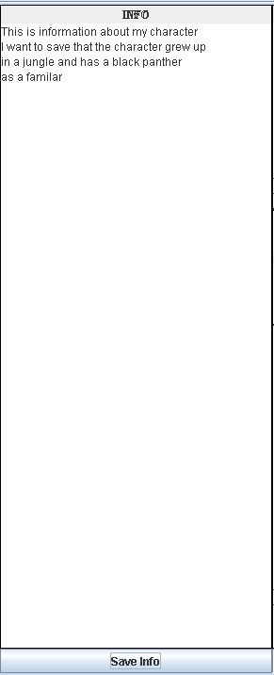

* + These are user generated notes.
    - A character must be built or loaded for this box to work
    - Do not use colons in the text to be entered
      * This will cause any information after the colon to not be saved correctly
    - There are some choices that will not be as specific as others. This is a good place to keep this information
    - Other things about the character can be kept here as well.
    - To use the info field
      * Type the information you want to remember about your character in the textbox.
      * If you want to go down a line, hit return
      * The box will autosize to the longest line in the list
      * When done entering information
        + Click the Save Info button
      * To remove information
        + Delete the information you want removed
        + Click the Save Info button
* Subclass Features

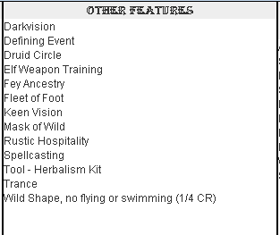

* + This is where any features given to the character based on their class, race or background will be placed
  + These values are entered automatically
* Proficiencies

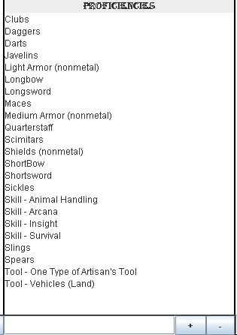

* + These are the things that your character is good at.
    - A character must be built or loaded for this box to work
    - Do not use colons in the text to be entered
      * This will cause any information after the colon to not be saved correctly
    - Classes, backgrounds and races all give certain proficiencies for various things
    - Skills the character knows will also be listed here
    - This box does allow for adding and removing proficiencies
      * To add a proficiency
        + Write the proficiency your character is learning in the text field
        + Click the + button
        + The proficiency will be added to the list above in alphabetical order.
      * To remove a proficiency
        + Write the proficiency your character is forgetting in the text field

The text must match exactly for the removal process to work

* + - * + Click the - button
        + The proficiency will be removed and the list redisplayed the options left alphabetically.
* Items

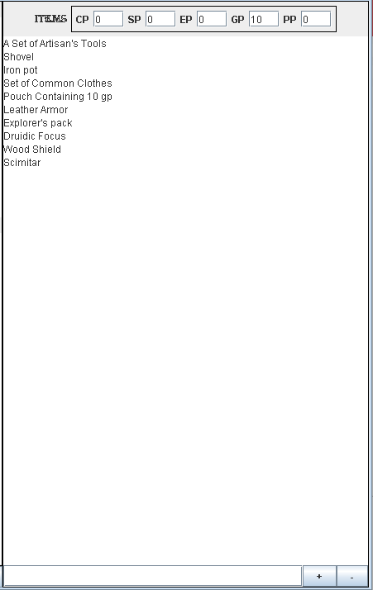

* + These are the things that your character is carrying.
    - A character must be built or loaded for this box to work
    - Do not use colons in the text to be entered
      * This will cause any information after the colon to not be saved correctly
    - The box at the top is the amount of each type of currency the character is carrying
    - Classes, backgrounds and races all give certain equipment for various things
    - Items that a character may pick up can be added here
    - This box does allow for adding and removing equipment
      * To add equipment
        + Write the equipment your character is collecting in the text field
        + Click the + button
        + The equipment will be added to the list above in alphabetical order.
      * To remove a equipment
        + Write the proficiency your equipment is removing in the text field

The text must match exactly for the removal process to work

* + - * + Click the - button
        + The equipment will be removed and the list redisplayed the options left alphabetically.

*Breakdown of the Spells tab*

* Spellcaster information

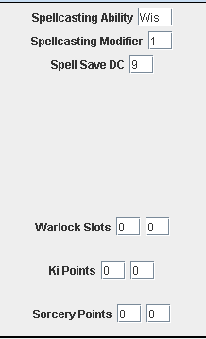

* + This box is filled out automatically
    - For more information on what this information means, please check the [SRD](https://5thsrd.org/) for the characters class.
      * Warlock Slots are specific to Warlocks
      * Ki points are specific to Monks
      * Sorcery Points are specific to Sorcerers
  + These values are entered automatically based on the characters class.
* Spell boxes

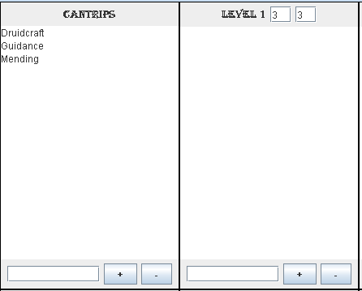

* + A character must be built or loaded for these boxes to work
  + Do not use colons in the text to be entered
    - This will cause any information after the colon to not be saved correctly
  + These boxes hold the various spells the character knows and the number of spells per level the character still has.
    - Cantrips and Race and Class Spells do not have a max number of spells that can be cast a day.
    - Spells for Level 1 to Level 9 have 2 number boxes at the top.
      * The box on the left is how many spells are left at that level
      * The box on the right is how many spells the character has max at that level
    - For more information on what this information means, please check the [SRD - Spells](https://5thsrd.org/#spellcasting)
  + How to enter spells
    - Cantrips
      * Cantrips can be chosen via choice boxes and placed here
      * Cantrips can also be added like regular spells.
    - All other spell boxes
      * The program does not have all the other levels of spells currently available as choice boxes. This is a feature for a later version
      * Please refer to the [SRD Spells by Level](https://5thsrd.org/spellcasting/spell_indexes/spells_by_level/) to learn which spells can be learned at which levels
    - Items that a character may pick up can be added here
    - This box does allow for adding and removing spells
      * To add a spell
        + Write the spell your character is learning in the text field
        + Click the + button
        + The spell will be added to the list above in alphabetical order.
      * To remove a spell
        + Write the spell the character forgetting in the text field

The text must match exactly for the removal process to work

* + - * + Click the - button
        + The spell will be removed and the list redisplayed the options left alphabetically.

**Refreshing the Character:**

Sometimes you need to reset your character to the most current information in the program. The Refresh button which is next to the subclass field will update the display to match what is running in the program. So if the character slept and they need their hitpoints and spell points recharged or to just make sure the program is showing the most up to date information.

To use the Refresh button

* Click the grey Refresh button in the top right corner
* The program will display the most current information on the character



**Leveling the Character:**

Character leveling is a large part of Dungeons and Dragons since it allows the character to grow, advance and mature. When this happens the character will gain a level. This program will help guide the user through the leveling process. For more information, please see the [SRD - Leveling Up](https://5thsrd.org/rules/leveling_up/)

*An important note: At this time, leveling down will be a feature implemented in a later version. It is our recommendation that the user is very careful leveling. If the character is incorrectly leveled, then the user must manually remove or ignore any features or abilities that may have been granted until that level is correctly attained Subclasses cannot be corrected if incorrectly chosen, the character will need recreation to fix this issue since there is no support for this issue.*

To level the character:



* Select the level dropdown
* Click on the next level up.
  + Characters can only be leveled on level at a time.
  + To build a higher level character,
    - Build a level 1 character then level up one level at a time to the appropriate level.
* If you have not yet chosen a save location for your character on your computer, a file directory box will appear

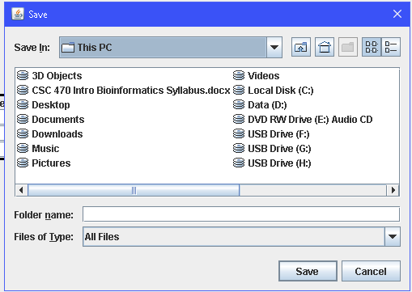

* + This is to allow your character to be saved.
    - Characters must have a save location in order to level
    - Characters are automatically saved when leveled
    - This will only appear if a save location has not been identified
      * See the section “Saving the Character” for more information.
* The correct experience will be applied to the character.
* Again, as a character is leveled, the user may have choice boxes appear as they are leveled
  + These boxes will be class specific
    - The number and content of the boxes will be determined by the characters class
    - Subclasses may be chosen as various levels, usually between level 1 and level 3.
      * Please check the class information in the SRD for more information
  + On levels 4, 8, 12, 16 and 19, all classes receive an ability scores box.
    - A character is not allowed to have their ability points go above 20
    - Some classes may have other levels with ability scores boxes

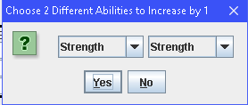

* + - The dropbox on the left will show only ability scores with a value of 19 or less.
    - The dropbox on the right will show only ability scores with a value of 18 or less.
    - Once both scores are chosen, click yes
      * +1 will be added to each score
      * All values that are based on ability scores will be recalculated automatically.
  + Once the choices are all made
    - The character will have all race, class and subclass information applied appropriately.
    - All level specific calculations will be rerun
  + When all the information is added to the character, the character is autosaved to the save location
  + The saved version of the character will then be displayed.

**Saving the Character:**

In many cases, the character created will be needed multiple times sometimes days or weeks apart. Saving the character allows for this. This will allow the character to be there when you need it. This feature also allows saving multiple characters, however, only one character can be active and used in the program at a time. In order to switch to a different character the previous character will be closed without saving unless the user saves the character first.

The first time that the program tries to save, load or delete a character, the file dialog box will appear and ask for the location to save or load the characters from. This will be chosen every time the program is opened. Once the file path has been specified, the dialog box will not reappear until the next time the program is opened.

To save the character

* Click File Menu
* Select Save from the file menu
* If the file path has not been chosen
  + The file dialog box will appear.
  + Otherwise skip this step



* + Navigate to the location on the computer you would like characters saved to.
    - It is recommended you create a specific folder to hold characters
  + Click save
* The character’s information will be saved to a text file with the characters name as the name of the text file.
  + The character will also be written to an index file called index.txt.
    - Do not delete this file or name a character ‘index’
      * Saved characters will not be loaded
* Once the character is done saving, a message box will pop up to confirm the character saved correctly.

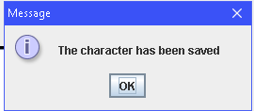

**Loading the Character:**

Being able to save the character is only helpful if the character can be reloaded to be updated. The first time that the program tries to save, load or delete a character, the file dialog box will appear and ask for the location to save or load the characters from. This will be chosen every time the program is opened. Once the file path has been specified, the dialog box will not reappear until the next time the program is opened.

To load a character:

* Click File Menu
* Select Load from the file menu
* If the file path has not been chosen
  + The file dialog box will appear.
  + Otherwise skip this step

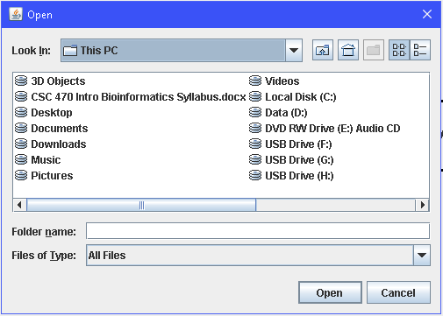

* + Navigate to the location on the computer the characters are saved at.
    - It is recommended you create a specific folder to hold characters
  + Click open
* The program will read the index file and return a list of saved characters in a message box.

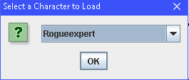

* Select the character to load from the dropdown box
* Click ok
* The character is read in from the characters save file and loaded to the program.
* The current character information is displayed and the character is ready to be used.

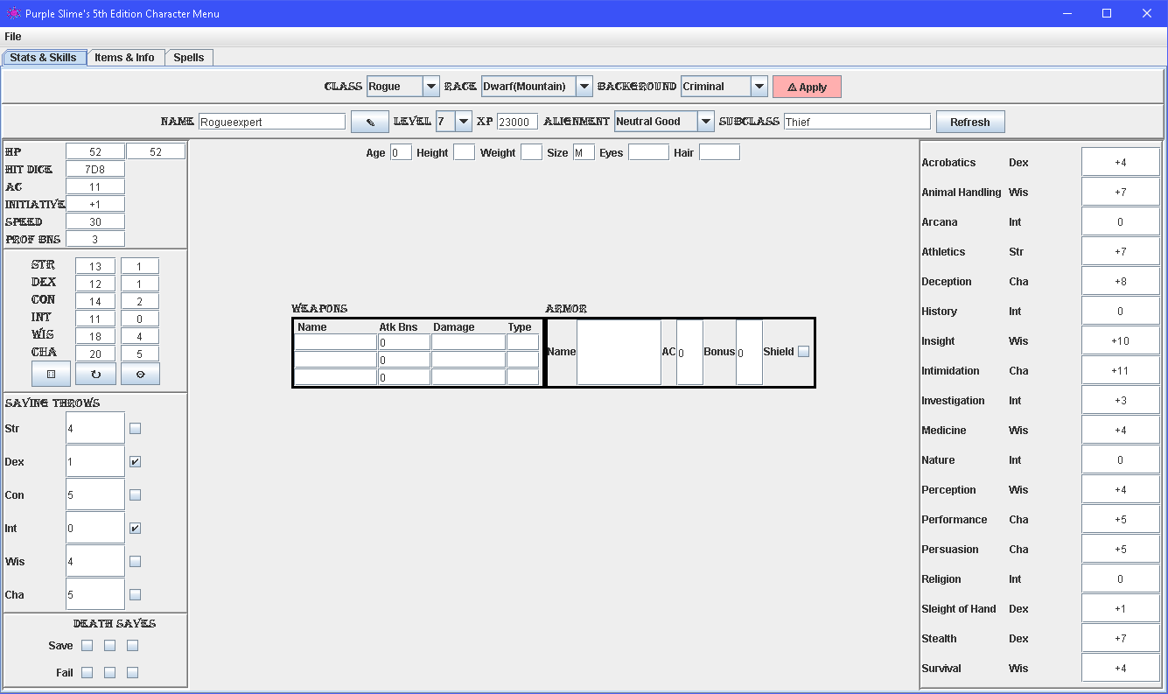

**Deleting a Character:**

Sometimes a character is no longer needed. It is recommended to delete characters when they are not open in the display. The first time that the program tries to save, load or delete a character, the file dialog box will appear and ask for the location to save or load the characters from. This will be chosen every time the program is opened. Once the file path has been specified, the dialog box will not reappear until the next time the program is opened.

To load a character:

* Click File Menu
* Select Delete from the file menu
* If the file path has not been chosen
  + The file dialog box will appear.
  + Otherwise skip this step



* + Navigate to the location on the computer the characters are saved at.
    - It is recommended you create a specific folder to hold characters
  + Click open
* The program will read the index file and return a list of saved characters in a message box.
  + Be careful at this step. Once a character is chosen, the deletion can not be undone

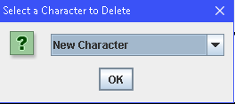

* Select the character to load from the dropdown box
* Click ok
* The character’s text file is deleted from the save location
* The characters information is removed from the index file called index.txt.
  + Do not delete this file
* When the deletion is complete, a message box will pop up confirming the deletion

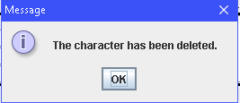

**All Done, Now What?:**

When you are done using the Purple Slime’s Character Menu there are three ways to close. This program does not save automatically on close. Only one method will save the character before exiting.

To close without saving

* Click the x in the top blue bar on the right side
* Click File Menu
  + Select Exit from the file menu

To closing with saving

* Click File Menu
  + Select Exit from the file menu
  + If the file path has not been chosen
    - The file dialog box will appear.
    - For more information on this, see Saving a Character
  + Once the save is complete, the program will close.